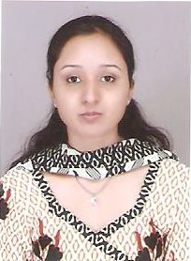

**H.NO. 41 Raksha Karamchari Colony,**

**Near Mastana Chowk, Ranjhi**

**JABALPUR (M.P) Pin:-482005**

**Mobile: - +91-9691754298**

**Email id: - sonal0927@gmail.com**

Ranjhi, Jabalpur (M.P)

Mobile: +91-9770255002

Email: [sonal0927@gmail.com](mailto:sonal0927@gmail.com)

**Sonal Singh**

# Objective:

To work in an organization with knowledge and skills and to develop myself for the progress of the organization.

**Educational qualifications**:

Post Graduate Diploma in Banking and Graduate in Bachelor of Engineering in Electronics and Telecommunication from Saraswati Institute of Engineering and Technology Jabalpur.

|  |  |  |  |  |  |
| --- | --- | --- | --- | --- | --- |
| S. No. | Class/Semester | School/College | Board/  University | Year | Percentage/CGPA |
| 1. | **PGDB** | **ICICI Manipal Academy** | **Manipal University** | **2015** | **7.5** |
| 1. | **BE-DEGREE** | **S.I.E.T JBP** | **R.G.P.V** | **2013** | **69.47%** |
| 10. | Class ${12}^{th}$ | Kendriya Vidyalaya OFK, Jbp | C.B.S.E | 2008 | 66.8 % |
| 11. | Class ${10}^{th}$ | St. Joseph’s Convent, Jbp | C.B.S.E | 2006 | 66.4% |

**Experience:**

*6 months experience in ICICI Bank Mumbai at the post of Deputy Manager Privilege Banking.

**Certificates:**

*NISM-Series V-A Mutual Fund Distributor Certificate

*NISM-Series-VI: Depository Operations Certificate

*IRDA Cerificate

**Key Skills:**

*Successfully maintained bank-customer relationship by being the one point of contact for all the customer queries.

*Successfully handled inventory and deliverables maintenance at branch level without errors.

*Successfully handled query desk and other desk at branch level.

*Successfully volunteered for checking all the official files and documents at the time of audits.

**Key Interest:**

*To work as a back bone of an organization by handling the customer queries and understanding their needs and requirements to help the bank grow its customer base. To handle all the process and operations and to learn new things and technologies to maintain and grow the effectiveness and accuracy of the company.

**Extra Curricular Activities:**

* Participated in organizing various events in college functions.
* Participated in various cultural activities at school level.
* Participated in every role play and events organized in Manipal Academy during PGDB course.

**Achievements:**

* Received many appreciation in maintaining proper record and accounts of documents during PGDB course.
* Received appreciations from lot of customers for resolving their queries properly.
* Received appreciations for communicating well with Privilege and HNI customers.

**Strengths:**

* Confident and Influensive.
* Honest, Sincere and Trustworthy.
* Good Team worker and Time Manager.
* Adaptive and Punctual.
* Loyal and Hard-working

**Hobbies:**

* Communicating with people.
* Reading Novels.
* Painting, drawing and sketching.
* Listening to music.

**Personal Profile:**

* Date of birth: 18th October, 1990
* Gender: Female
* Nationality: Indian
* Languages known: Hindi, English
* Father’s name: Mr. Ashutosh Singh
* Mother’s name: Mrs. Tarla Singh

**Declaration:**

I hereby declare that the above information is true to best of my knowledge.

Date: 17-04-2015 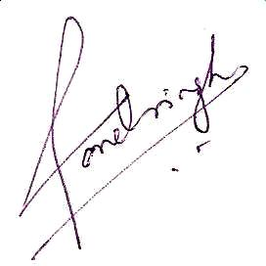Place: JABALPUR Signature